Allison’s Book Corner
June 2020

The Way Through The Woods: On Mushrooms and Mourning
by Long Litt Woon

This is one of those little special books that one could easily miss in the course of their reading life. It came to my attention through a patron who stopped at the Help Desk eagerly looking for this book. I could not understand her excitement. Mushrooms? Death? Widow? What?

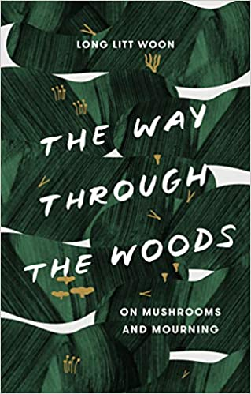
Before you read any further, picture what comes into your mind when you first hear the word “mushroom.” In this country, we are used to mushrooms in fine dining, or maybe as a pizza topping or tossed in a salad. Some of us think of drugs and “magic mushrooms.”

At first glance, you may ask what in the world could mushrooms have to do with grieving? Is there really a connection or is this a gimmick to lure skeptical readers to read this memoir about a non-celebrity in a faraway country? Here I will quote the author, who says, “Reading a book is like taking a walk through an unknown country.” In this memoir, we readers walk into Norway and into the world of mushrooming.

Picking and gathering mushrooms for eating certainly is not done only in Norway. Our author had signed up for a beginner’s course on mushrooms and mushroom foraging with her husband when he suddenly died. This hobby is very popular in Norway. The country has a very large society devoted to the study of mushrooms and fungi (mycology). Google “mycology” and you will find mushroom enthusiast societies across the United States and the world.

The amazing thing about this memoir is that the author is able to interest us not only in mushrooms and all of the different varieties (of which there are 10,000 to date) but in how she handles her grief while becoming a mushroom inspector (yes, that job exists). Unlike other famous memoirs concerning grief, this is not a sad memoir. The reader is not crying after reading every chapter. Rather, one is compelled to keep reading. Most of us already know that many mushroom varieties are poisonous and can cause harm and death if eaten. But I bet you did not know that there are mushrooms that grow as big as pumpkins, some that ooze red liquid when cut, and actual bioluminescent mushrooms that light up the forest at night. Crazy, isn’t it?

Long Litt Woon is Malaysian and she married a Norwegian man, remaining in his country of birth after his sudden, unexpected death. She walked around in a bit of a fog and stupor when her partner of thirty-two years suddenly disappeared. Foraging through beautiful Norwegian forests alone looking for mushrooms was her therapy, at first. But to really distinguish between different mushroom varieties (the deadly and the edible), all of your senses have to be used. As can happen with any significant loss, our author experiences a numbness to all of her senses. Delving into mushrooming forced her senses to reawaken. Lovely memories of her husband are interspersed throughout the book. She was one of the fortunate with a very good, happy marriage and she recognizes that she was blessed. The lesson of this memoir is not really how to handle grief, but rather the story of one woman and how she handled grief in her life. And, as we read about her, something awakens in each of us. It is a beautifully-written memoir. The author even shares some of her most tasty mushroom recipes.

With great joy I can tell you that the New York Mycological Society (of course we have one) has an NPR interview with the author on its website (newyorkmyc.org). Click “News” and scroll down the page. There is a picture of our beautiful author. She spoke in Central Park last summer, and the NPR interview is there. You should listen. Thank me later.

Finally, with a tip of the hat to Long Litt Woon, I offer a recording of a recent webinar produced by New York’s Mohonk Preserve, “Introductory Mycology for the Curious Naturalist.”

